**PROJECT REPORT - SOURCER’s TRAIL**



**SUBMITTED BY-**

**Team ALPHA**

**CERTIFICATE**

We hereby certify that the work presented in the Project Report entitled “SOURCER’S TRAIL”, in partial fulfillment of the requirements for the certificate of the CYBER SECURITY: ATTACK AND DEFENCE SUMMER INTERNSHIP PROGRAM and submitted to Indira Gandhi Delhi Technical University For Women, is an authentic record of our own work carried out during the period from 3rd JUNE, 2019 TO 28th JUNE ,2019 under the supervision of Mr. Urvin Mistry and Ms. Manisha Meena.

Team ALPHA

**AKNOWLEDGEMENT**

Presentation inspiration and motivation have always played a key role in the success of any venture.

We express our deep sense of gratitude to Dr. ARUN SHARMA (HOD) of IT Department, IGDTUW for encouraging us to the highest peak and to providing us the opportunity to prepare the project.

We feel to acknowledge our indebtedness and heartfelt obligation to our mentors Mr. Urvin Mistry and Ms. Manisha Meena , whose valuable guidance and kind supervision throughout the course shaped the present work as its show.

Thanking you

**ABSTRACT**

The project tests the knowledge of the user about “security vulnerability assessment tools such as DVWA with the latest vulnerabilities and the latest OWASP 10 vulnerabilities” by means of a game which has various levels with varying difficulties. User’s performance is depicted through a leaderboard wherein the user can check his/her scores and is ranked among the various other users playing the game.

**OBJECTIVE**

To develop a game which merges the concept of sourcing games with the knowledge of security vulnerability assessment tools such as DVWA with the latest vulnerabilities and the latest OWASP 10 vulnerabilities.

**INTRODUCTION**

In sourcing games, we will try to find out the password for unlocking each level using our skills, ability and knowledge from the given code. We will analyze the code and try to find and guess the correct password. These games are designed to increase our knowledge about how to find passwords in one time through practically working on the cues. Following applications are used for developing the project which are listed as: -

* XAMPP
* DVWA
* PHP Storm
* VS code
* Virtual Studio
* Sublime Text

**PREREQUISITES**

* PHP
* SQL
* HTML
* CSS
* Java Script

**OPERATING ENVIRONMENT**

Languages used:

* PHP: used to interact with the database languages, here MYSQL.
* SQL: used for creating the databases.
* HTML: used to create web pages to format text as title and headings and to arrange link to different pages within a website.
* CSS: used for describing the presentation of web pages, including colors, layout and fonts.
* Java Script: scripting language which used within HTML pages. It is used primarily by web browsers to create a dynamic and interactive experience for the use. JavaScript is mainly used in building websites and web applications.

**SOFTWARE REQUIRED**

1. XAMPP: XAMPP is use to Run Your Own Web Server. XAMPP stands for Cross-Platform (X), Apache (A), MySQL (M), PHP (P) and Perl (P). It is a simple, lightweight Apache distribution that makes it extremely easy for developers to create a local web server for testing purposes.

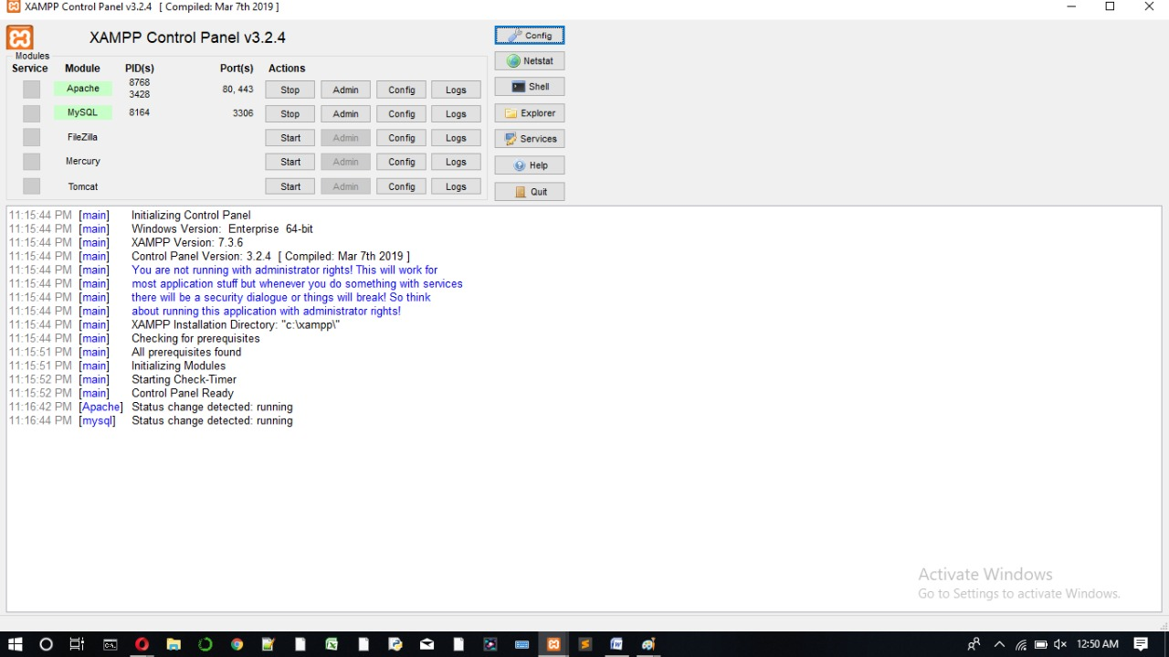

1. Sublime Text 3: Sublime Text is a proprietary cross-platform source code editor with a Python application programming interface (API). It natively **supports** many programming languages and markup languages (such as html, php, css), and it is used for compile the code in a localhost server and making the connection with the databases.
2. PHP Storm: PHP Storm is a cross-platform IDE that works on Windows, macOS and Linux. It also provides an editor for PHP, HTML and JavaScript code. It is built on IntelliJ IDEA, which is written in java. It also provides error prevention and automated refactoring for PHP and JavaScript code.

**HARDWARE REQUIRED**

1. Operating system: Windows 10, LINUX
2. Processor: Intel core i5
3. 4 GB RAM

**FUNCTIONING**

Registration and Login:

1. Allows for typing in user information including Name, Username, Email id, Gender.
2. User Id and Password will be provided to each User.
3. User can reset their password.
4. User can access their account using the email id and password.

5. The credentials of the User will be secured.

* The Registration web page will act as an interface between the user and the service, giving the user a unique id for accessing the data.

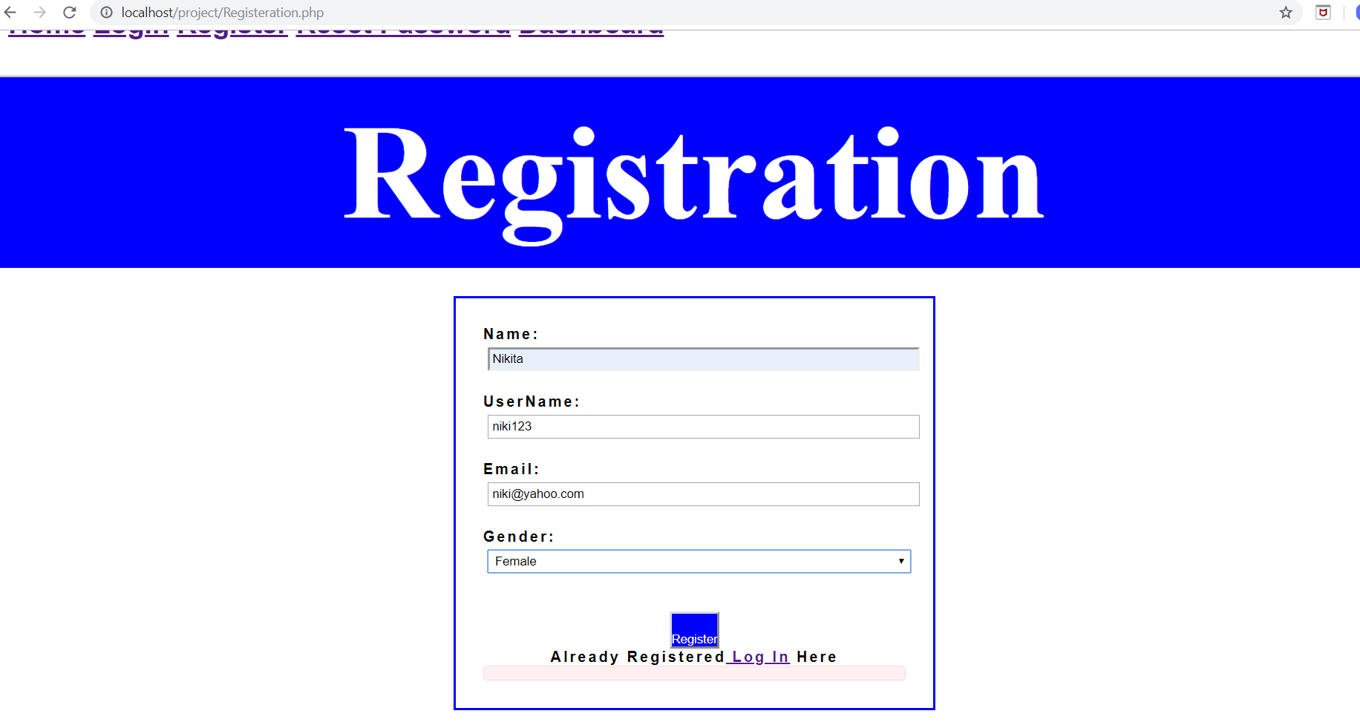

* It is used for the authentication of user through sending one time password to the user’s email id.

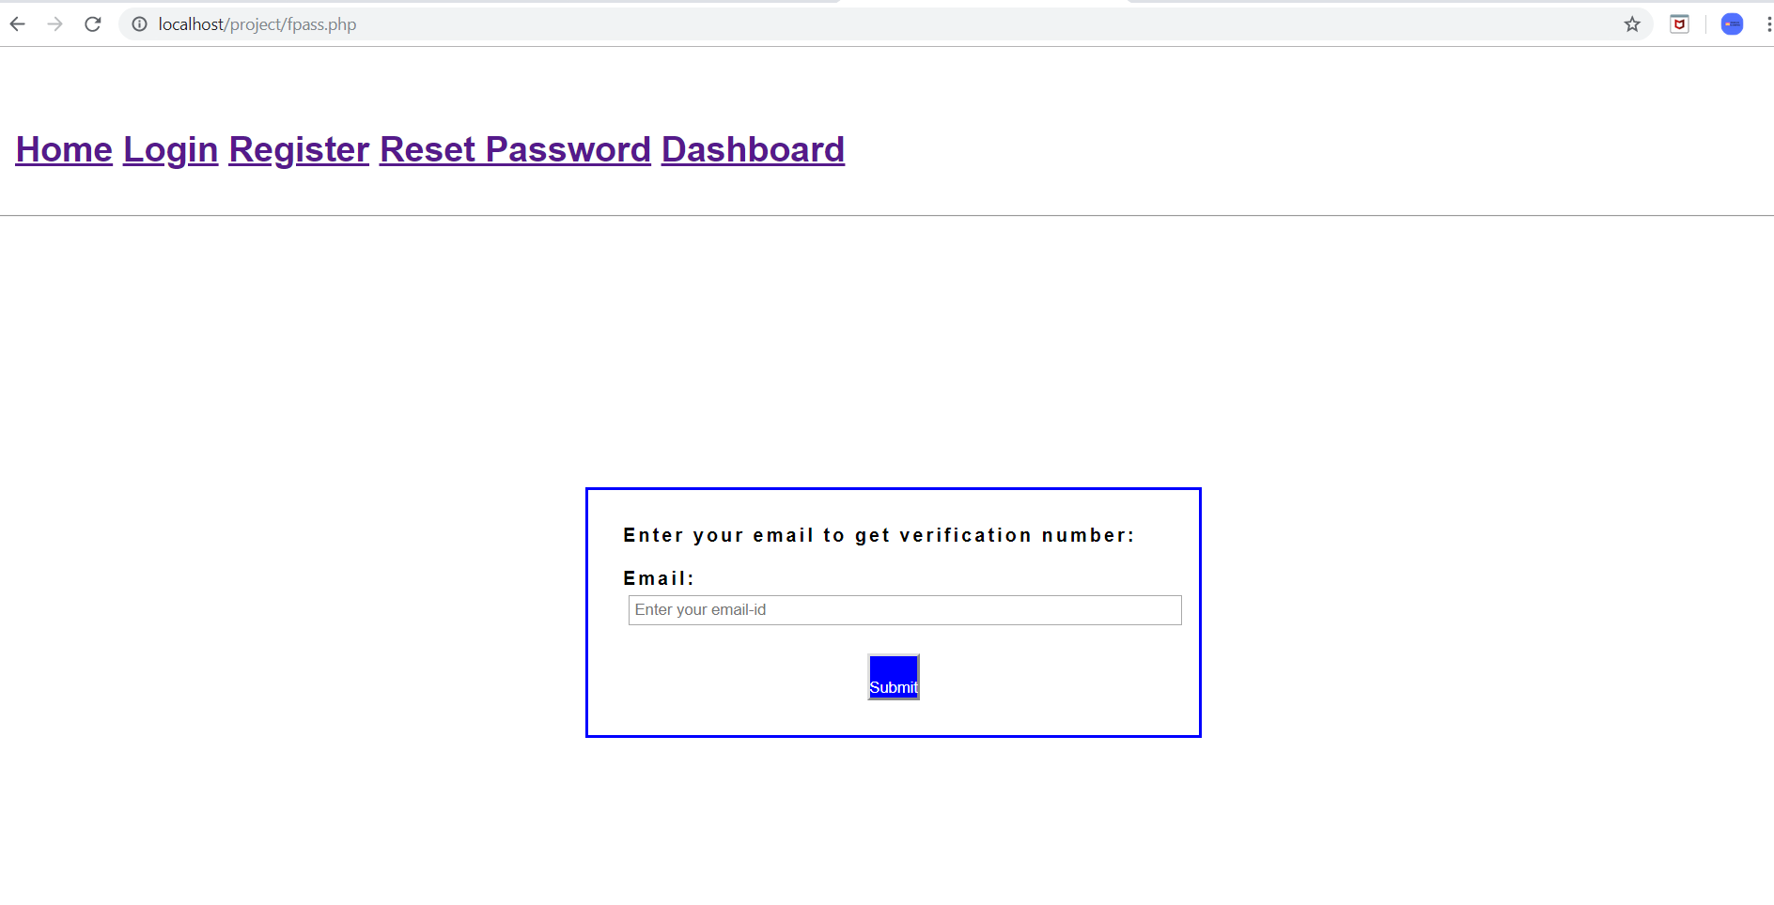

* It is the page where the user will provide the old password and enter the new password.

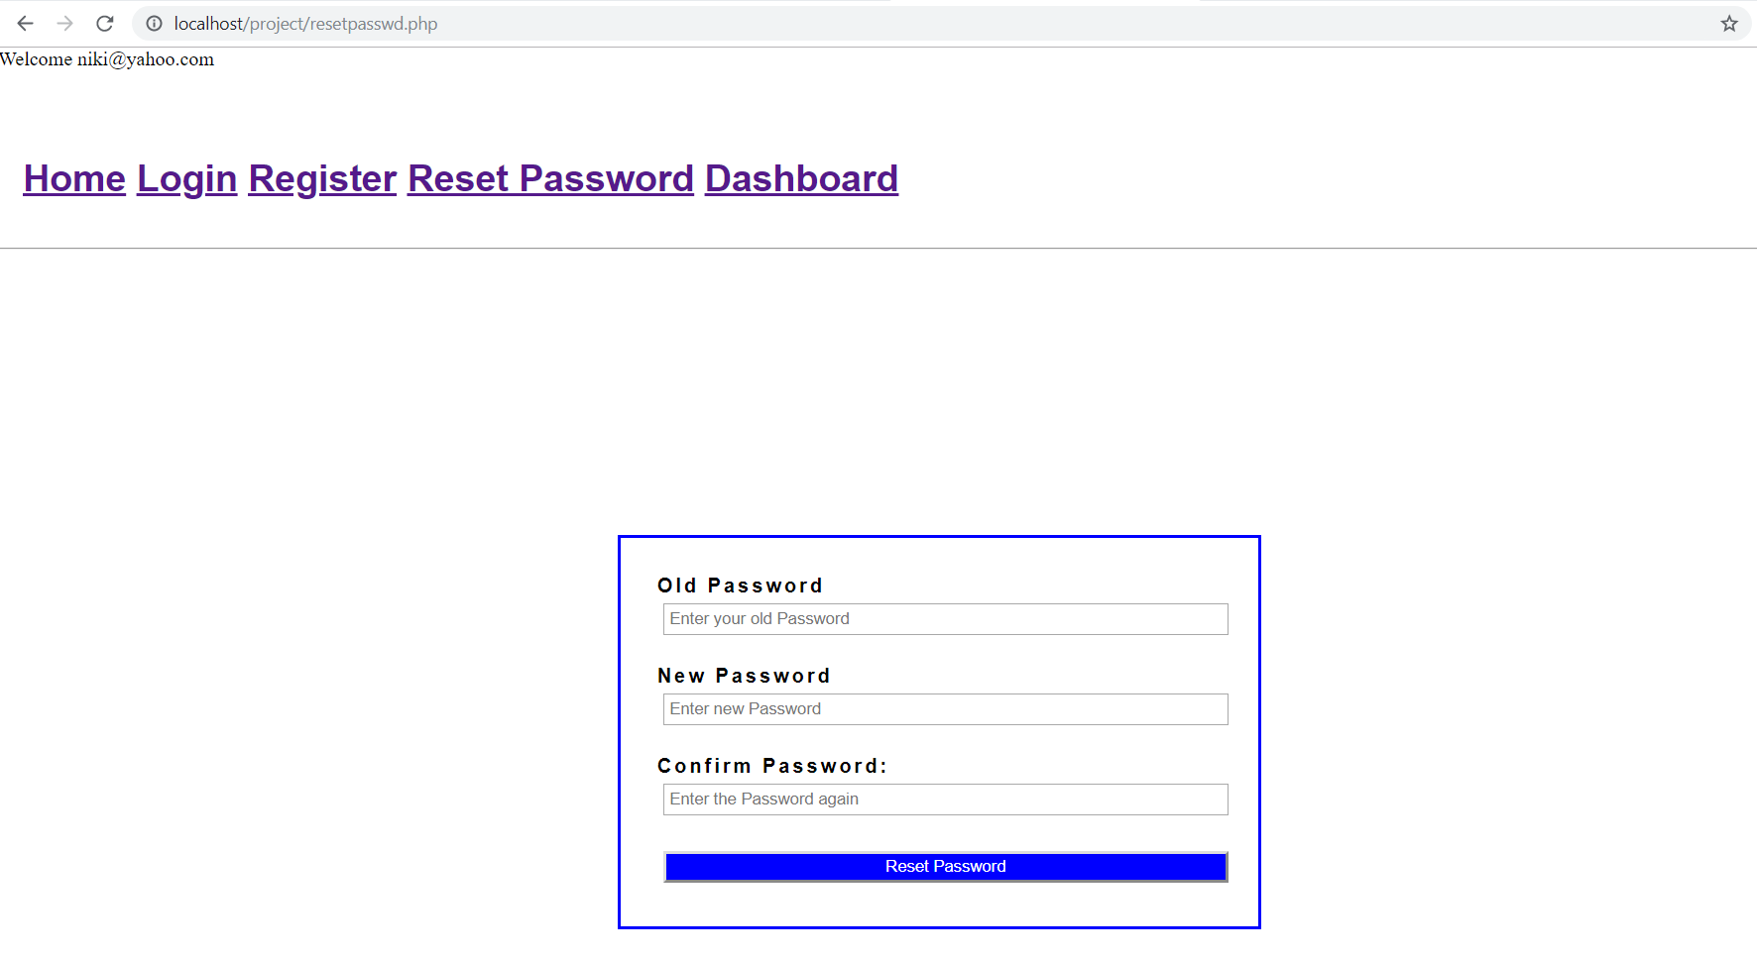

* It is the page where the user will login using email id and password.

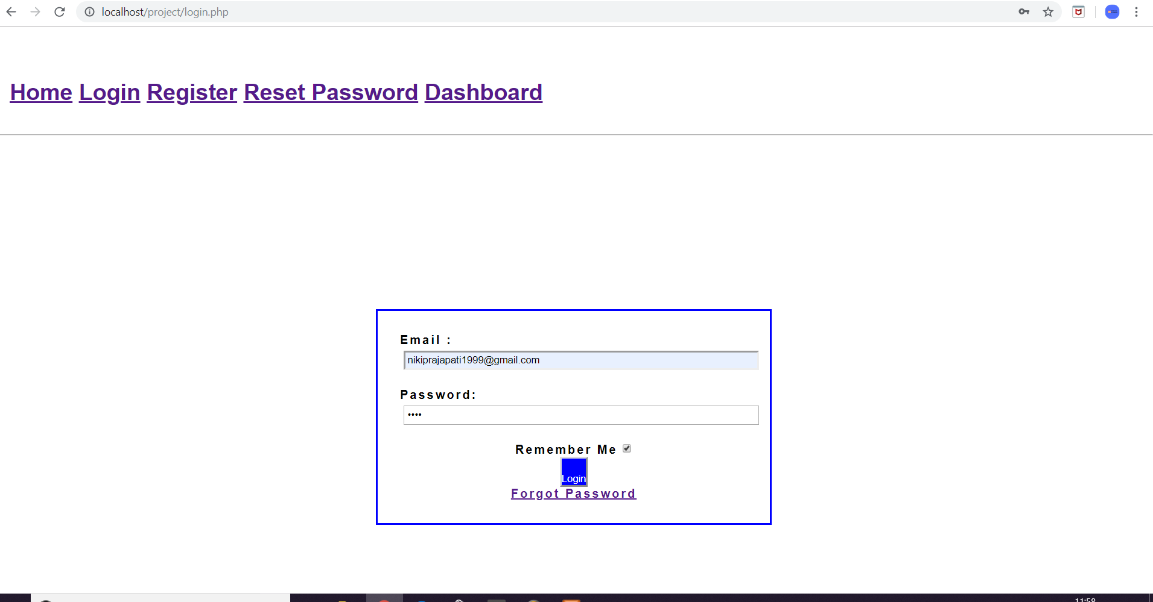

**DATABASE**

There are two entities:

1. Leader_board

Attributes:

* Uid (User ID): it is the unique id of the user.
* Score: It is the score of the user as per the performance in the game.
* Level_1
* Level_2
* Level_3
* Level_4
* Level_5
* Level_6
* Level_7

1. User

Attributes:

* Uid (User ID): It is the unique id of the user.
* Name: It is the name of the user (as provided by the user).
* Username: It is the actual name of the user.
* Email: It is the email id of the user.
* Passwd: Password)
* Gender

**UML Diagrams**

* Use Case Diagram:

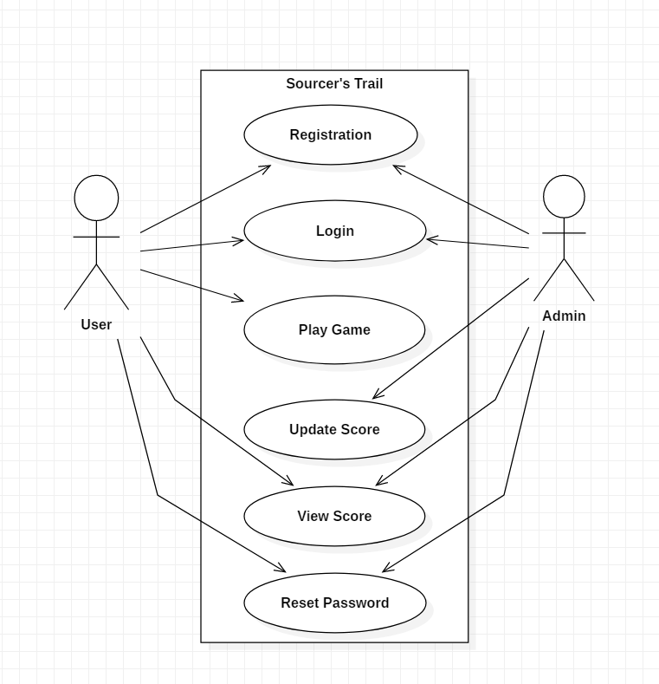

* ER Diagram

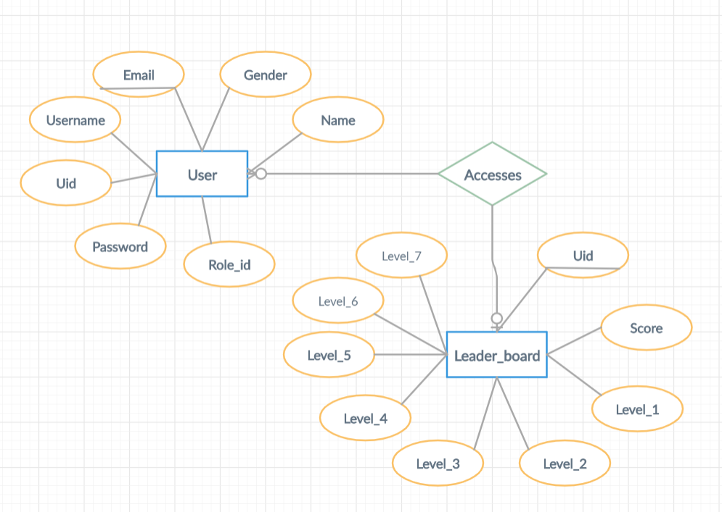

* Data Flow Diagram

